Project report template

1.Introduction

1.1.Overview

A brief description about your project

1.2.Purpose

The use of the project.what can be achieved using this.

2.Problem definition&Design thinking

2.1.Empathy Paste the empathy map screenshot. 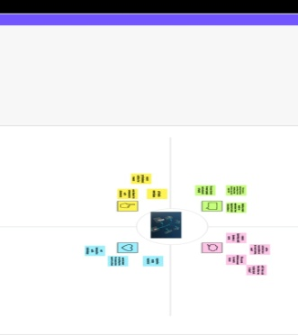

2.2.Ideation&brainstorming map

Patse the ideation&brainstorming map screenshot

3.Result

Find findings(output) of the project along with screenshots.

4.Advantages &disadvantages

\*Petrol or diesel vehicles are highly polluting and are being quickly replaced by fully electric vehicles.

\*Electric vehicles have the silent functioning capacity as there is no engine under the hood.

5.Applications

\*Tax and financial benefits:Registration fees and road tax on purchasing electric vehicles are lesser than petrol or diesel vehicles.

6.conclusion

\*Conclusion summarizing the entire work and findings.

7.Future scope

\*Enhancements that can be made in the future.

8.Appendix

A source code

Attach the code for the solution built.